**Project Start Date: 11-Sep-2018**

**Project Submission Date: 11-Oct-2018**

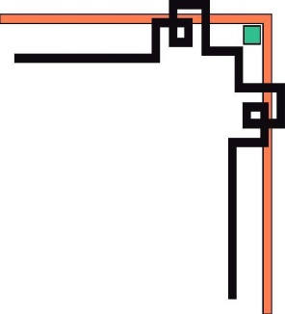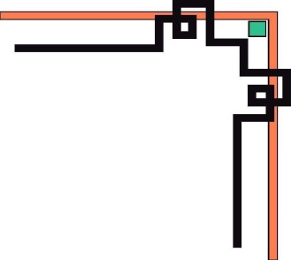

**eProject SEM-3**

**.NET**

**Project: Karnel Travel**

***Group 3:***

Student1058384 HUY DANG TUAN (LT)

Student1007818 SON PHAM NGUYEN HOANG

Student1111738 PHONG TRAN TRUNG

Student989084 NHI NGUYEN THI YEN

***Supervisor:***

MY LINH ONG THI

1. **Problem Definition**

***(Form No. 1/eProjects/PS/Ver1.0)***

Karnel Travels is a company which provides the various transportation facilities between the cities like tourist spots, transportation between different cities in the country, also provides accommodations in hotels, etc. Also, they provide the online facility where the customers can visit online, view and order for the tours and as well the transportation. Now they want to build a website, provide better service to customers. Website providing various information services such as the list of tourist spot, information about the various hotels and restaurants, etc. Their website has an URL in internet. So, they approached us to build a website for them.

***Benefits of building website Karnel Travel***

Website KarnelTravels.net was built to improve the quality of service of the company. The first, the technological advancements these days it allows businesses to manage and maintain the content of the web application and keep track of all the records of client’s interest and bookings in the most effective manner. The Second, Travel & Tourism collaborates with businesses with almost every transport service provider like railway, airways, sea etc. Therefore, for making your travel & tourism website a successful you must collaborate with transport and booking providers for making a good travel & tourism web application for its users. The Third, Karnel Travel web applications are developed taking all the measures and implementations which make it safer and secure both clients and business owners. Plus, it keeps all the client’s information safe from everyone. Therefore, Karnel Travel companies should hire a good web application development company for developing a secure website. Finally, A Karnel Travel web application should act as a single web application for booking tickets, hotels, sightseeing, car rentals, and sometimes travel related shopping as well. Moreover, for all these, you are not required to create a single portal for each of them. Plus, people these days prefer everything at one place.

1. **Customer requirement specification (CRS)**

***(Form No. 2/eProjects/PS/Ver1.0)***

## ***Client: Karnel Travel Company***

Karnel is an experienced travel management company

## ***2.2 Business/Project Objective***

***Karnel Travel Company needs to be constructed considering following requirements:***

We work with you to manage all elements of your travel in an efficient, cost effective and ethical manner. The company has now evolved into a highly respected purpose driven VietNam owned travel management company. Karnel Travel is committed to making a difference in the world that its clients travel to, whether on business, on holiday or on a study tour.

***Karnel Travel*** is website Book travel(e-commerce), which Introduce and display **Tourists Spot.** We can contact for users to review tourist Spot as well as suggestions on the company's services. Finally, Customers can search, Book travel of company or Feedback

## ***2.3 Requirements and Scope***

|  |  |
| --- | --- |
|  | ***Requirements*** |
| **Input provided by Client** | 1. ***Inputs to the existing system***  * **Admin:** Username, Password * **Customer:** Customer Id, Password, Last Name, FirstName, Birthday, Gender, Phone, Address, Email, Passport * **About:** About Id, Name, Birth, Gender, Like, Image * **Feedback:** Feedback, Sender Name, Sender Mail, Feedback Title, Feedback Content, State, Create on * **Foods:** Food Code, Name, Price, Specific, Image, * **Hotels:** Hotel Id, Name, Address, Details, Image, Restaurants Id * **Location:** Location Id, Name * **Restaurants:** Restaurant Code, Name, Address, Description, Image, * **Rooms:** Room Id, Type, Name, Start, Stop, Cost, Image, Hotel Id   Tourist Spot: Tourist Spot Id, Name, Limit, Price, Specific, Status, Image, Location Id   * **Transportations:** Transportation Id, Name, Details, Image, Tourist Spot Id * **Tourists Spot:** Tourist Spot Id, Tourist Spot Name, Tourist Spot Limit, Tourist Spot Price, Tourist Spot Specific, Tourist Spot Status, Location Id * **Trip:** Trip Id, Name, Details, Date, Address, Status, Customer Id * **Trip Details:** Trip Id, Tourist Spot Id, Trip Quantity * **Vehicle:** Vehicle Id, Name, Price, Weight, Image, Transportation Id * **Payment Method:** Payment Id, Name  1. ***Output from the existing system***  * List of Restaurant/ Foods/ Hotels/ Rooms/ Vehicle/ Payment method/ Transportations/ Location…) * Price List of Trip * Information of Trip * Book Trip  1. ***Process involved in the application (Admin and User)***  * Register * Login * Show list of Restaurants * Show list of Foods * Show list of Hotels * Show list of Rooms * Show list of Transportations * Show list of Vehicle * Show list of Tourist Spot * Feedback * Search (Cars, Motors) * Book Trip (Order Trip)  1. ***Expected delivery dates***  * Project Start Date: **11-Sep-2018** * Project Submission: **11-Oct-2018**  1. ***List of Deliverables***  * Document   Customer Requirement Specification   * DFD * Process Diagrams   Design document   * DB Design / Structures * Flow Charts * ER Diagrams * Data Structures   User Guide / Installation Guide  Check list  Database (SQL Azure or MS SQL Server)   * Website   Deployment website using windows Azure  Source Code |
| **Hardware** | * ***Client:***   HDD: 150G or larger (You can use SDD)  CPU: Intel core i3 or higher  Network: Card or WIFI  RAM: 2G or higher   * ***Server***   HDD: 1TB or larger  CPU: Intel core i7/AMD: 2.6 GHz or higher  RAM: 4G or larger |
| **Software** | * ***Client:***   OS: Win 7/ Win 8/ Win 10/Linux/Ubuntu/Mac OS  Browser: Firefox/Chrome/Opera   * ***Server:***   OS: Win2K8, Win2K12, Win2K16, Ubuntu Server, VPS, Azure…  Browser: Firefox/Chrome/Opera  MS SQL Server 2012 (or higher) /SQL Azure  .NET Framework 3.5 |
| **Scope of the Work (in brief)** | * The URL should be <http://www.Karneltravelguide.com> * The website should contain a menu through which the different topics can be fetched out with an ease. * The menu should contain the following:   + Home Page   + About Us   + Search page   + Information Page * Tourist Spots available with in the country. * Travel Information * Hotel Information * Restaurant Information. * Resorts Information   + Contact Us * The About Us Page should include the details about the company, also it should include the details about the facilities that it will provide like transportation, packages, transportation and accommodation facility to tourist locations, etc. * The Search page should implement the search for the various tourist spots like beaches, monuments, etc. and also it should include the search for the Hotels, Restaurants and resorts based on the location, price, quality, quantity and availability. Also, on this page there should be a link for the advanced search page. * The information page should contain 5 links as mentioned above and it should display the information about the new hotel’s restaurants and the resorts information also if there is any package or discounts that the company is providing can also be displayed. * Tourist spots should include the various tourist locations available with in the country. * Travel information should include the various transportation facilities available with in the country. * Similarly, the various hotels, restaurants and resorts that are available with in the country should be displayed for the Hotels, Restaurants, and resorts information. * The contact us Page is the page where the customer can contact the company for placing an order and this page should also include the feedback, which will collect the feedback from the various users of the website.   Reviews Service of Karnel Travel such as: hotels, rooms, food, vehicles, … Before, you create planning of vacation. |

1. **Architecture & Design of System**

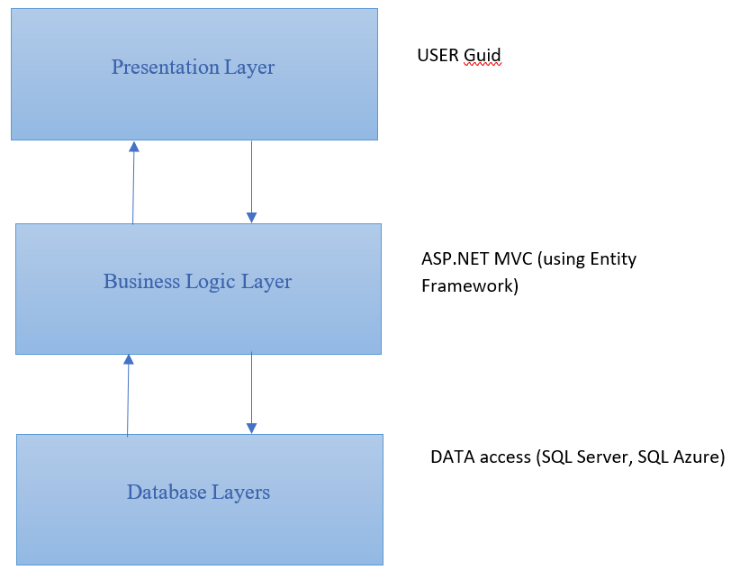 ***(Form No. 3/eProjects/PS/Ver1.0)***

***Web-Based Distributed 3-Layer Architecture of the Project***

1. **Data Flow Diagrams (DFD)**

***(Form No. 5/eProjects/PS/Ver1.0)***

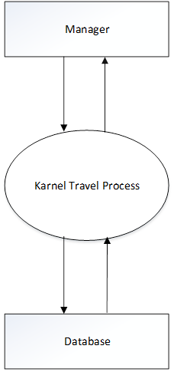**4.1 Context diagram:**

* 1. **DFD level 0**



* 1. **DFD Level 1**



* 1. **DFD Level 2.1**



* 1. **DFD Level 2.2**



* 1. **DFD Level 2.3**



* 1. **DFD Level 2.4**



1. **Flow Charts**

***(Form No. 6/eProjects/PS/Ver1.0)***

## ***Create Account Admin***

**Create Account Admin**

## ***Login Adminstrator***



**Login Admin Page**

## ***Add : Restaurants, Hotels, Foods, Vehicle, Rooms, Tourist Spot, Transportation***



## ***Update Information Trip***



## ***Delete***



## ***Search***



## ***Book Travel (Cart)***



## **Check out Book travel**



1. **Entity Relationship Diagrams**

***(Form No. 8/eProjects/PS/Ver1.0)***

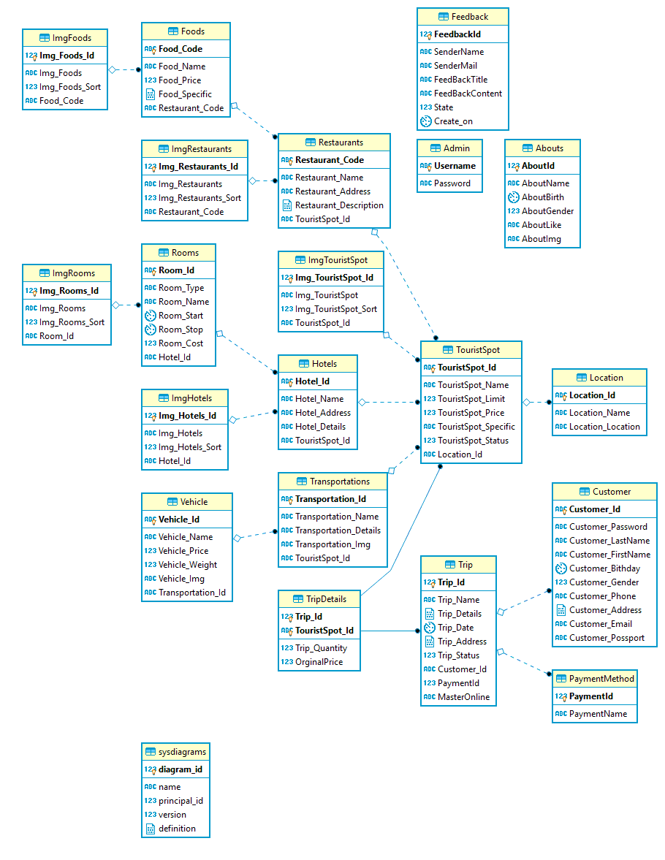

1. **Data modeling (SQL SERVER)**

***(Form No. 9/eProjects/PS/Ver1.0)***



1. **Data Dictionary**

***(Form No. 10/eProjects/PS/Ver1.0)***

## ***Admin***

|  |  |  |  |  |
| --- | --- | --- | --- | --- |
| **Table: Admin** | | | | |
| **Fields** | **Data Type** | **Allow Nulls** | **Key** | **Description** |
| Username | nvarchar(20) |  | Primary Key | Store the username of Administrator |
| Password | nvarchar(32) |  |  | Store the password |

## ***Customer***

|  |  |  |  |  |
| --- | --- | --- | --- | --- |
| **Table: Customer** | | | | |
| **Fields** | **Data Type** | **Allow Nulls** | **Key** | **Description** |
| Customer_Id | nvarchar(20) | Not Nulls | Primary Key |  |
| Customer_Password | nvarchar(32) | Nulls |  |  |
| Customer_LastName | nvarchar(20) | Nulls |  |  |
| Customer_FirstName | nvarchar(20) | Nulls |  |  |
| Customer_Bithday | date | Nulls |  |  |
| Customer_Gender | bit | Nulls |  |  |
| Customer_Phone | nvarchar(20) | Nulls |  |  |
| Customer_Address | ntext | Nulls |  |  |
| Customer_Email | nvarchar(50) | Nulls |  |  |
| Customer_Possport | nvarchar(20) | Nulls |  |  |

## ***TripDetails***

|  |  |  |  |  |
| --- | --- | --- | --- | --- |
| **Table:TripDetails** | | | | |
| **Fields** | **Data Type** | **Allow Nulls** | **Key** | **Description** |
| Trip_Id | nvarchar(20) | Not Nulls | Primary Key, Foreign key |  |
| TouristSpot_Id | nvarchar(20) | Not Nulls | Primary Key, Foreign key |  |
| Trip_Quantity | int | Nulls |  |  |

## ***ImgFoods***

|  |  |  |  |  |
| --- | --- | --- | --- | --- |
| **Table: ImgFoods** | | | | |
| **Fields** | **Data Type** | **Allow Nulls** | **Key** | **Description** |
| Img_Foods_Id | int | Not Nulls | Primary Key |  |
| Img_Foods | nvarchar(Max) | Nulls |  |  |
| Img_Foods_Sort | tinyint | Not Nulls |  |  |
| Food_code | nvarchar(20) | Nulls | Foreign key |  |

## ***Feedback***

|  |  |  |  |  |
| --- | --- | --- | --- | --- |
| **Table: Feedback** | | | | |
| **Fields** | **Data Type** | **Allow Nulls** | **Key** | **Description** |
| FeedbackId | int | Not Nulls | Primary Key |  |
| SenderName | nvarchar(50) | Nulls |  |  |
| SenderMail | nvarchar(50) | Nulls |  |  |
| FeedBackTitle | nvarchar(40) | Nulls |  |  |
| FeedBackContent | nvarchar(150) | Nulls |  |  |
| State | bit | Not Nulls |  |  |
| Create_on | datetime | Not Nulls |  |  |

## ***Foods***

|  |  |  |  |  |
| --- | --- | --- | --- | --- |
| **Table: Foods** | | | | |
| **Fields** | **Data Type** | **Allow Nulls** | **Key** | **Description** |
| Food_code | nvarchar(20) | Not Nulls | Primary Key |  |
| Food_Name | nvarchar(20) | Nulls |  |  |
| Food_Price | decimal(12,2) | Nulls |  |  |
| Food_Specific | ntext | Nulls |  |  |
| Restaurant_Code | nvarchar(20) | Nulls | Foreign key |  |

## ***ImgRestaurants***

|  |  |  |  |  |
| --- | --- | --- | --- | --- |
| **Table: ImgRestaurants** | | | | |
| **Fields** | **Data Type** | **Allow Nulls** | **Key** | **Description** |
| Img_Restaurants_Id | int | Not Nulls | Primary Key |  |
| Img_Restaurants | nvarchar(max) | Nulls |  |  |
| Img_Restaurants_Sort | tinyint | Not Nulls |  |  |
| Restaurant_Code | nvarchar(20) | Nulls | Foreign key |  |

## ***Restaurants***

|  |  |  |  |  |
| --- | --- | --- | --- | --- |
| **Table: Restaurants** | | | | |
| **Fields** | **Data Type** | **Allow Nulls** | **Key** | **Description** |
| Restaurant_Code | nvarchar(20) | Not Nulls | Primary Key |  |
| Restaurant_Name | nvarchar(20) | Nulls |  |  |
| Restaurant_Address | nvarchar(150) | Nulls |  |  |
| Restaurant_Description | ntext | Nulls |  |  |
| TourisSpot_Id | nvarchar(20) | Nulls | Foreign key |  |

## ***ImgRoom***

|  |  |  |  |  |
| --- | --- | --- | --- | --- |
| **Table: ImgRoom** | | | | |
| **Fields** | **Data Type** | **Allow Nulls** | **Key** | **Description** |
| Img_Rooms_Id | int | Not Nulls | Primary Key |  |
| Img_Rooms | nvarchar(max) | Nulls |  |  |
| Img_Rooms_Sort | tinyint | Not Nulls |  |  |
| Room_Id | nvarchar(20) | Nulls | Foreign key |  |

## ***Room***

|  |  |  |  |  |
| --- | --- | --- | --- | --- |
| **Table: Room** | | | | |
| **Fields** | **Data Type** | **Allow Nulls** | **Key** | **Description** |
| Room_Id | nvarchar(20) | Not Nulls | Primary Key |  |
| Room_Type | nvarchar(20) | Nulls |  |  |
| Room_Name | nvarchar(20) | Nulls |  |  |
| Room_Start | time(7) | Nulls |  |  |
| Room_Stop | time(7) | Nulls |  |  |
| Room_Cost | money | Nulls |  |  |
| Hotel_Id | nvarchar(20) | Nulls | Foreign key |  |

## ***ImgHotel***

|  |  |  |  |  |
| --- | --- | --- | --- | --- |
| **Table: ImgHotel** | | | | |
| **Fields** | **Data Type** | **Allow Nulls** | **Key** | **Description** |
| Img_Hotels_Id | int | Not Nulls | Primary Key |  |
| Img_Hotels | nvarchar(Max) | Nulls |  |  |
| Img_Hotels_Sort | tinyint | Not Nulls |  |  |
| Hotel_Id | nvarchar(20) | Nulls | Foreign key |  |

## ***Hotel***

|  |  |  |  |  |
| --- | --- | --- | --- | --- |
| **Table: Hotel** | | | | |
| **Fields** | **Data Type** | **Allow Nulls** | **Key** | **Description** |
| Hotel_Id | nvarchar(20) | Not Nulls | Primary Key |  |
| Hotel_Name | nvarchar(120) | Nulls |  |  |
| Hotel_Address | nvarchar(255) | Nulls |  |  |
| Hotel_Detail | nvarchar(Max) | Nulls |  |  |
| TourisSpot_id | nvarchar(20) | Nulls | Foreign key |  |

## ***Transportations***

|  |  |  |  |  |
| --- | --- | --- | --- | --- |
| **Table: Transportations** | | | | |
| **Fields** | **Data Type** | **Allow Nulls** | **Key** | **Description** |
| Transportations_Id | nvarchar(20) | Not Nulls | Primary Key |  |
| Transportations_Name | nvarchar(100) | Not Nulls |  |  |
| Transportations_Detail | nvarchar(255) | Nulls |  |  |
| Transportations_Img | nvarchar(150) | Nulls |  |  |
| TourisSpot_id | nvarchar(20) | Nulls | Foreign key |  |

## ***Abouts***

|  |  |  |  |  |
| --- | --- | --- | --- | --- |
| **Table: Abouts** | | | | |
| **Fields** | **Data Type** | **Allow Nulls** | **Key** | **Description** |
| AboutId | int | Not Nulls | Primary Key |  |
| AboutName | nvarchar(50) | Nulls |  |  |
| AboutBirth | date | Nulls |  |  |
| AboutGender | bit | Nulls |  |  |
| AboutLike | nvarchar(150) | Nulls |  |  |
| AboutImg | nvarchar(250) | Nulls |  |  |

## ***Vehicle***

|  |  |  |  |  |
| --- | --- | --- | --- | --- |
| **Table: Vehicle** | | | | |
| **Fields** | **Data Type** | **Allow Nulls** | **Key** | **Description** |
| Vehicle_Id | nvarchar(20) | Not Nulls | Primary Key |  |
| Vehicle_Name | nvarchar(25) | Nulls |  |  |
| Vehicle_Price | decimal(12, 0) | Nulls |  |  |
| Vehicle_Weight | int | Nulls |  |  |
| Vehicle_Img | nvarchar(50) | Nulls |  |  |
| Transportations_Id | nvarchar(20) | Nulls | Foreign key |  |

## ***Trip***

|  |  |  |  |  |
| --- | --- | --- | --- | --- |
| **Table: Trip** | | | | |
| **Fields** | **Data Type** | **Allow Nulls** | **Key** | **Description** |
| Trip_Id | nvarchar(20) | Not Nulls | Primary Key |  |
| Trip_Name | nvarchar(25) | Not Nulls |  |  |
| Trip_Detail | ntext | Nulls |  |  |
| Trip_Date | datetime | Nulls |  |  |
| Trip_Address | ntext | Nulls |  |  |
| Trip_Status | bit | Nulls |  |  |
| Customer_Id | nvarchar(20) | Nulls | Foreign key |  |

## ***Location***

|  |  |  |  |  |
| --- | --- | --- | --- | --- |
| **Table: Location** | | | | |
| **Fields** | **Data Type** | **Allow Nulls** | **Key** | **Description** |
| Location_Id | nvarchar(20) | Not Nulls | Primary Key |  |
| Location_Name | nvarchar(20) | Nulls |  |  |
| Location_Location | nvarchar(20) | Nulls |  |  |

## ***ImgTouristSpot***

|  |  |  |  |  |
| --- | --- | --- | --- | --- |
| **Table: Img_TouristSpot** | | | | |
| **Fields** | **Data Type** | **Allow Nulls** | **Key** | **Description** |
| Img_TouristSpot_Id | int | Not Nulls | Primary Key |  |
| Img_TouristSpot | nvarchar(MAX) | Not Nulls | Primary Key |  |
| Img_TouristSpot_Sort | tinyint |  |  |  |
| TouristSpot_Id | nvarchar(20) |  | Foreign key |  |

## ***TouristSpot***

|  |  |  |  |  |
| --- | --- | --- | --- | --- |
| **Table: TouristSpot** | | | | |
| **Fields** | **Data Type** | **Allow Nulls** | **Key** | **Description** |
| TouristSpot_Id | nvarchar(20) | Not Nulls |  |  |
| TouristSpot_Name | nvarchar(30) | Nulls |  |  |
| TouristSpot_Limit | int | Nulls |  |  |
| TouristSpot_Price | decimal(12, 0) | Nulls |  |  |
| TouristSpot_Specific | nvarchar(20) | Nulls |  |  |
| TouristSpot_Img | nvarchar(50) | Nulls |  |  |
| Localtion_Id | nvarchar(20) | Nulls | Foreign key |  |

## ***PaymentMethod***

|  |  |  |  |  |
| --- | --- | --- | --- | --- |
| **Table: PaymentMethos** | | | | |
| **Fields** | **Data Type** | **Allow Nulls** | **Key** | **Description** |
| PaymentId | int | Not Nulls |  |  |
| PaymentName | varchar (50) | Nulls |  |  |

1. **Site Map**

***(Form No. 11/eProjects/PS/Ver1.0)***

## Admin



## 10.2 User

1. **Task Sheet**

***(Form No. 12/eProjects/PS/Ver1.0)***

|  |  |  |  |  |  |  |  |  |
| --- | --- | --- | --- | --- | --- | --- | --- | --- |
| **Project Ref. No: 1**  **Ep/Advertisement Portal Management System/01** | | **Project Titles:**  **Karnel Travel** | **Activity Plan Prepared By:**  Huy Dang Tuan | **Date of Preparation of Activity Plan:**  Project Start Date: 11-Sept-2018 | | | | |
| Sr.No | Task | **Actual Start Date** | **Actual Days** | **Team Mate Names** | **Status** | **Total Status** |
|  |  |  |  |  |  |  |  |  |
|  |  |  |  |  |  |  |  |  |
|  |  |  |  |  |  |  |  |  |
|  |  |  |  |  |  |  |  |  |
|  |  |  |  |  |  |  |  |  |
|  |  |  |  |  |  |  |  |  |
|  |  |  |  |  |  |  |  |  |
|  |  |  |  |  |  |  |  |  |
|  |  |  |  |  |  |  |  |  |
|  |  |  |  |  |  |  |  |  |
|  |  |  |  |  |  |  |  |  |
|  |  |  |  |  |  |  |  |  |
|  |  |  |  |  |  |  |  |  |
|  |  |  |  |  |  |  |  |  |
|  |  |  |  |  |  |  |  |  |
|  |  |  |  |  |  |  |  |  |
|  |  |  |  |  |  |  |  |  |
|  |  |  |  |  |  |  |  |  |
|  |  |  |  |  |  |  |  |  |
|  |  |  |  |  |  |  |  |  |
|  |  |  |  |  |  |  |  |  |
|  |  |  |  |  |  |  |  |  |
|  |  |  |  |  |  |  |  |  |
|  |  |  |  |  |  |  |  |  |
|  |  |  |  |  |  |  |  |  |
|  |  |  |  |  |  |  |  |  |
|  |  |  |  |  |  |  |  |  |
|  |  |  |  |  |  |  |  |  |
|  |  |  |  |  |  |  |  |  |
|  |  |  |  |  |  |  |  |  |
|  |  |  |  |  |  |  |  |  |
|  |  |  |  |  |  |  |  |  |
|  |  |  |  |  |  |  |  |  |

1. **Check list Validation**

***(Form No. 13/eProjects/PS/Ver1.0)***

|  |  |
| --- | --- |
| Option | Validated |
| Do all numeric variables have a default values or zeros? | Yes |
| Does the administrator have all the rights to create and delete record? | Yes |
| Are all the records properly fed into the appropriate database? | Yes |
| Have all the modules been properly integrated and are completely function? | Yes |
| Have all the design and coding standards been followed and implemented? | Yes |
| Is the design consistent all over? | Yes |
| Is the navigation sequence current through all the screens in the application? | Yes |
| Is exception handing mechanism implemented in all the screens? | Yes |
| Are all the programs codes working? | Yes |

1. **Submission Checklist**

***(Form No. 14/eProjects/PS/Ver1.0)***

|  |  |  |  |  |  |
| --- | --- | --- | --- | --- | --- |
| **Sr. No** | **Particulars** | **Yes** | **No** | **NA** | **Comments** |
| **1.** | Have all the modules been properly integrated and are they completely functional? | X |  |  |  |
| **2.** | Does each unit meet its objective and purpose?  Are all the validations happen as specified in Process Design? | X |  |  |  |
| **3.** | Have all Design and Coding standards been followed and implemented? | X |  |  |  |
| **4.** | Is GUI design consistent all over? | X |  |  | Includes admin page and the user page (Responsive web design) |
| **5.** | Are the codes working as per the specification? | X |  |  |  |
| **6.** | Does the application’s functionality resolve the client problem, and satisfy his/her needs completely? | X |  |  |  |
| **7.** | Have the Hardware and software been correctly chosen? | X |  |  |  |
| **8.** | Additional features and utilities that give values addition to the entire project | X |  |  | Using Captcha, Bootstraps, jQuery, Page List…. |

1. **User Guid and Install eProject**

***(Form No. 15/eProjects/PS/Ver1.0)***

## System Requirement:

|  |  |  |
| --- | --- | --- |
| No. | Items | Description |
| 1 | Operating System | Win 7, Win 8.1 or higher |
| 2 | Database | SQL 2012-2017 (using SQL 2014) |
| 3 | Software | Visual Studio 2017 Pro with Asp.Net MVC template |

## Install and Run App

13.2.1 SQL Server local (2014)

* Go to link: <https://www.microsoft.com/en-us/download/details.aspx?id=42299>
* Choose SQL
* 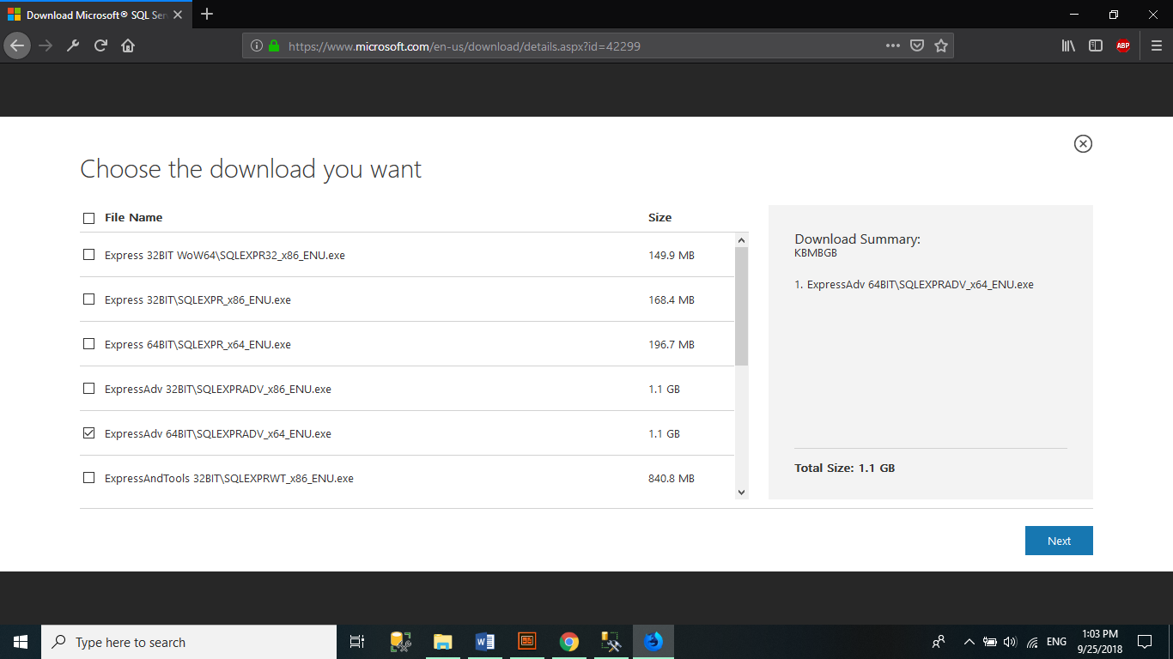Download

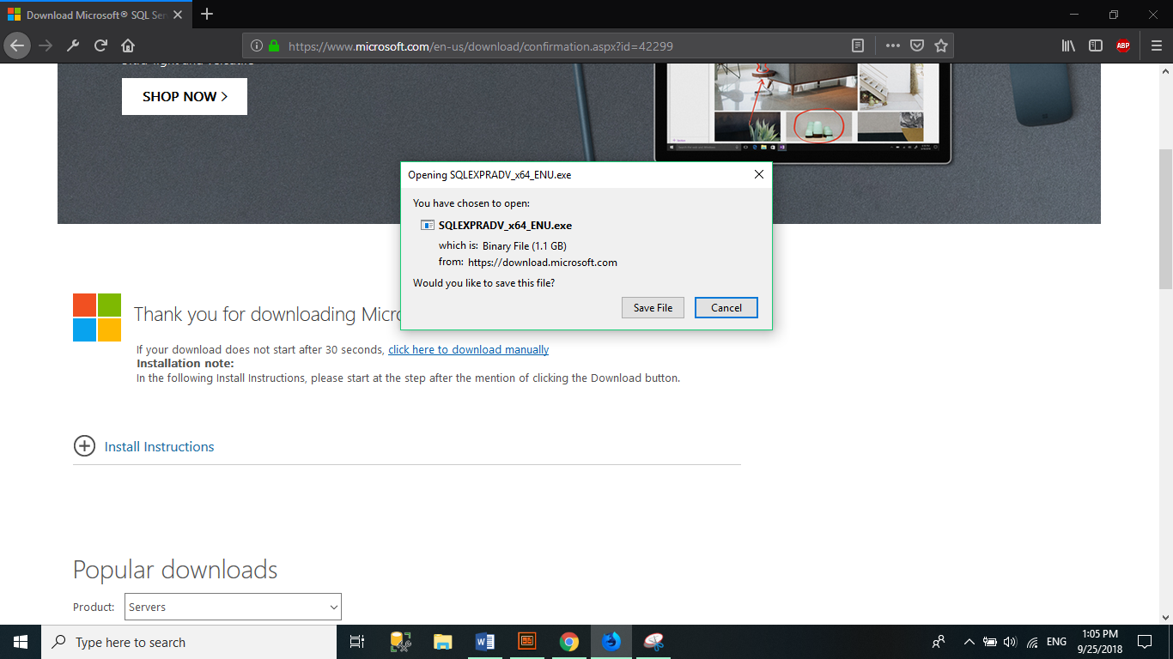

* Install step by step
* 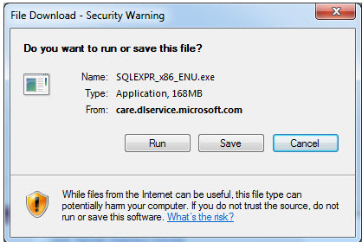**Step 1:** Click on the downloaded file and **Run** the file.
* 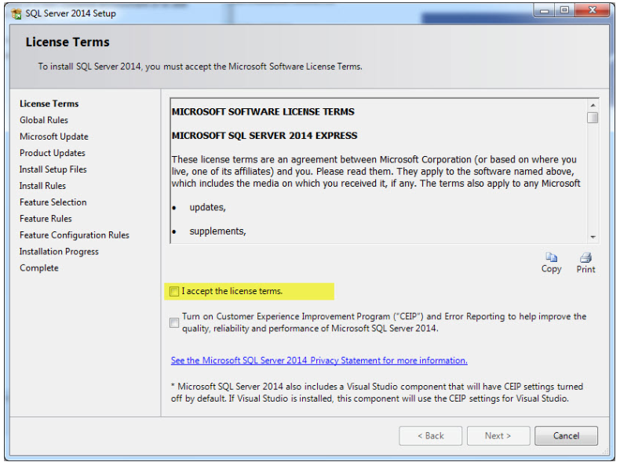**Step 2: Accept the license terms and click**Next**.**
* 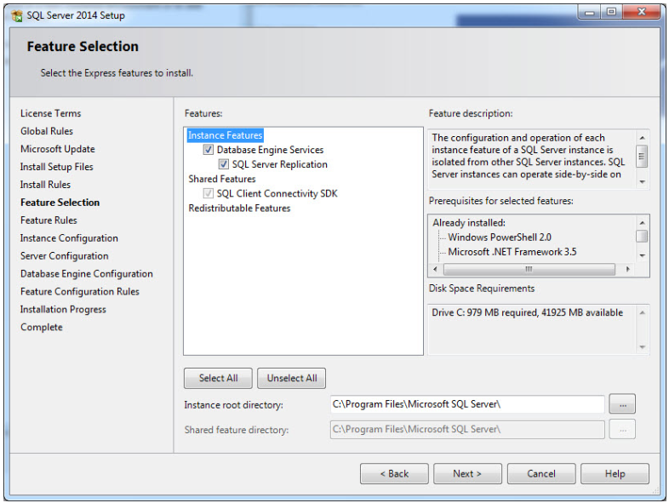**Step 3: On the Feature Selection screen, keep the defaults**
* **Step 4: On instance configuration screen, select “**Named Instance**” and name the database you want and click.**

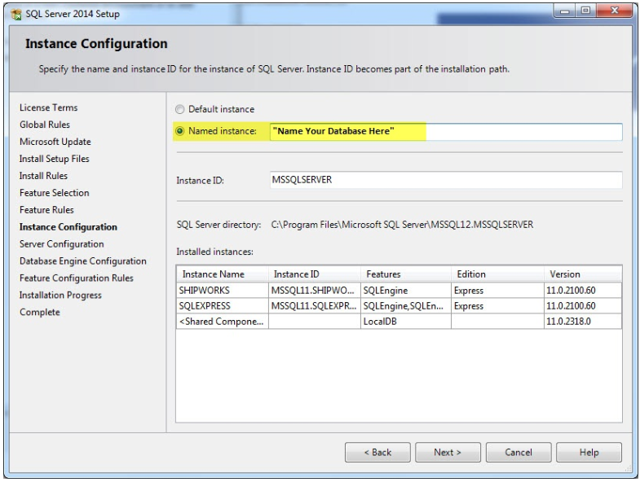

* 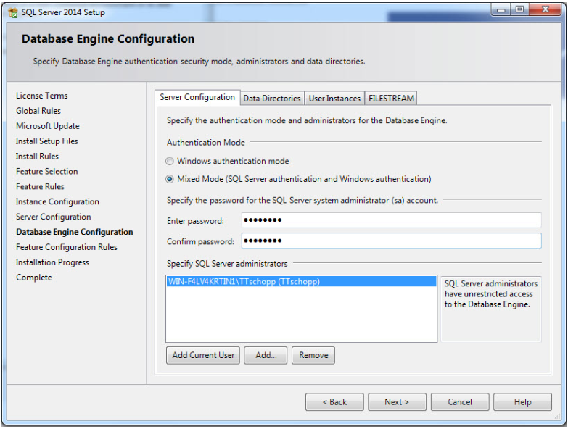**Step 5: Click**Next**until you get to the**Database Engine Configuration**screen and select**Mixed Mode. **Don’t forget to save login details and passwords in another document.**

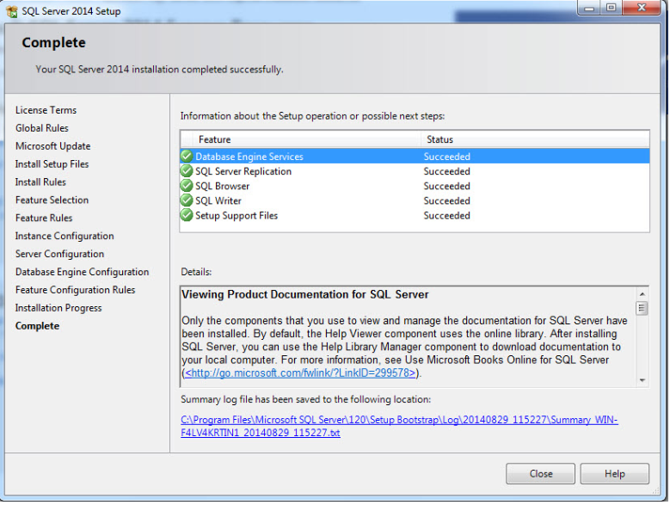**Step 6:** **Click**Next**until your setup is complete. Click**Close**.**

* 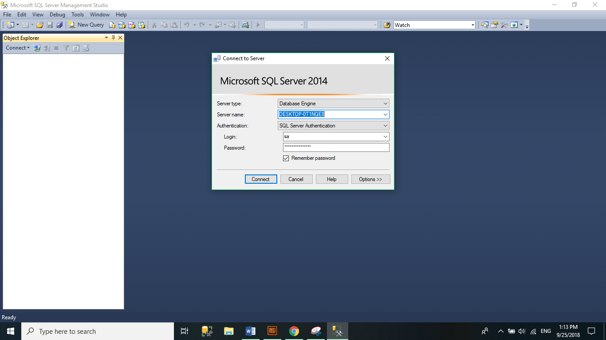**Result**

13.2.2 Visual Studio 2017 Pro

* Go to link: <https://visualstudio.microsoft.com/downloads/>
* 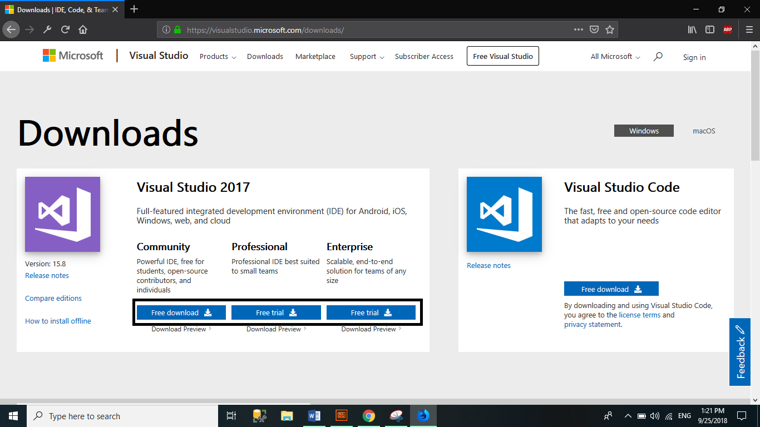Download
* Install file exe after download
* Choose features

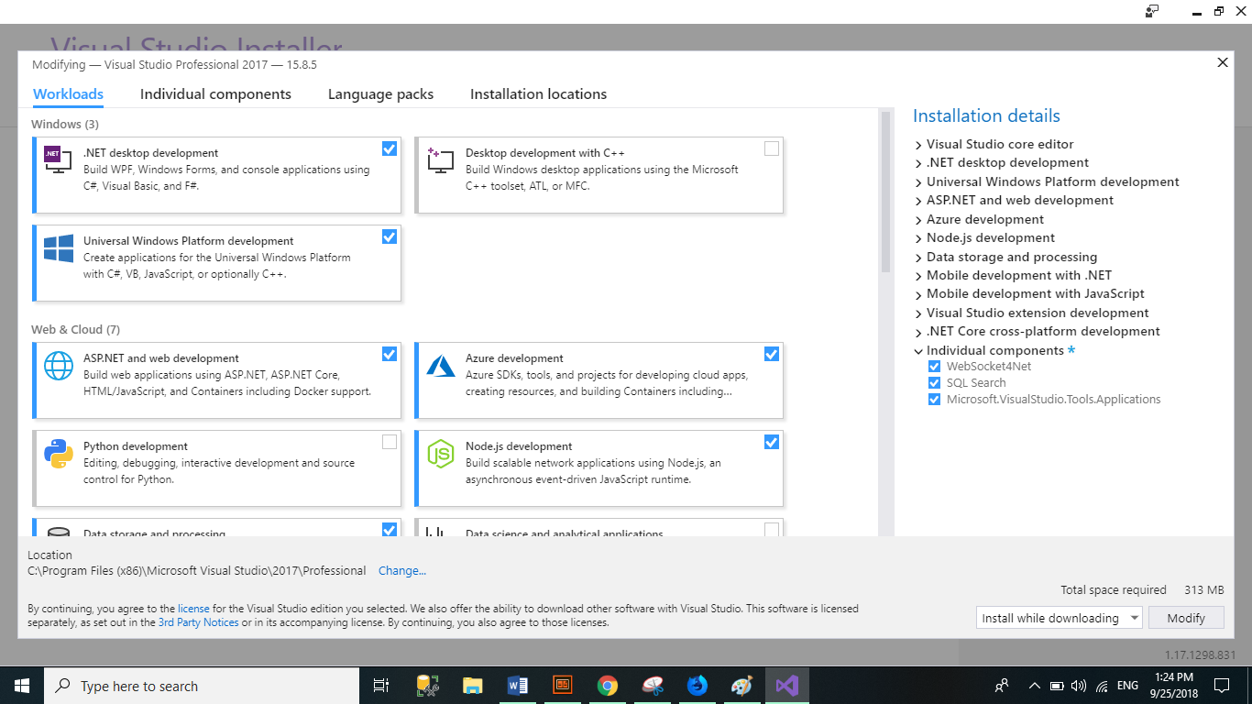

* Click Install
* 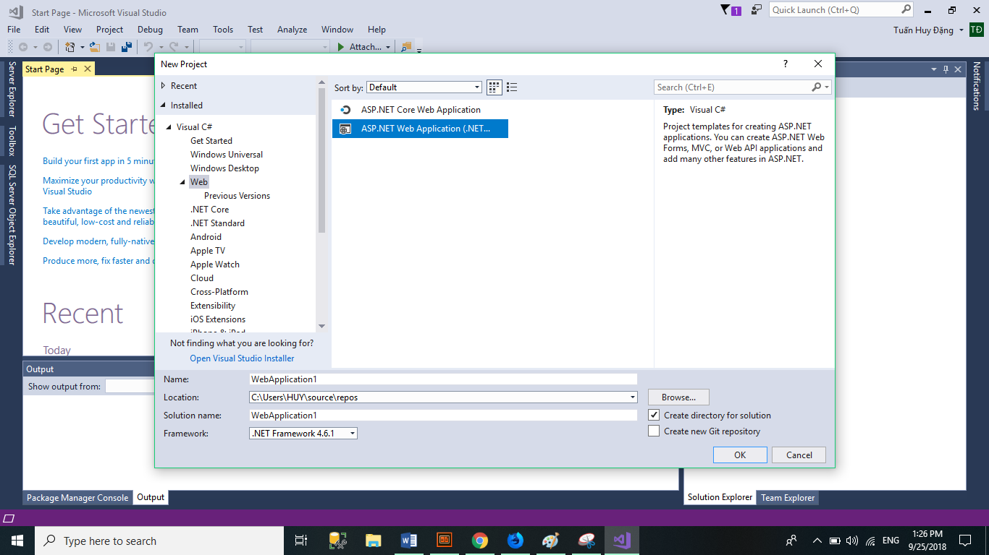Result

## User GUI

13.3.1. Config SQL 2014 and VS 2017 Pro

13.3.2. Administrator

* Login with username: dangtuanhuy and password: dangtuanhuy
* 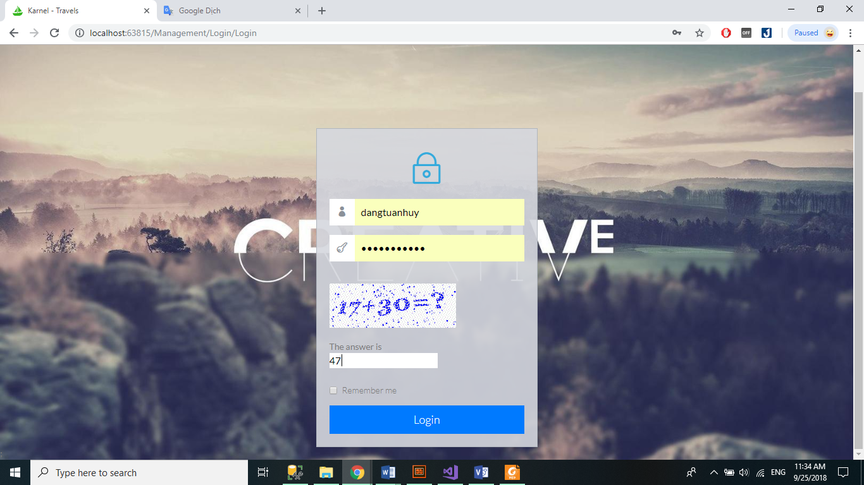Interface Admin Page Karnel Travel
* 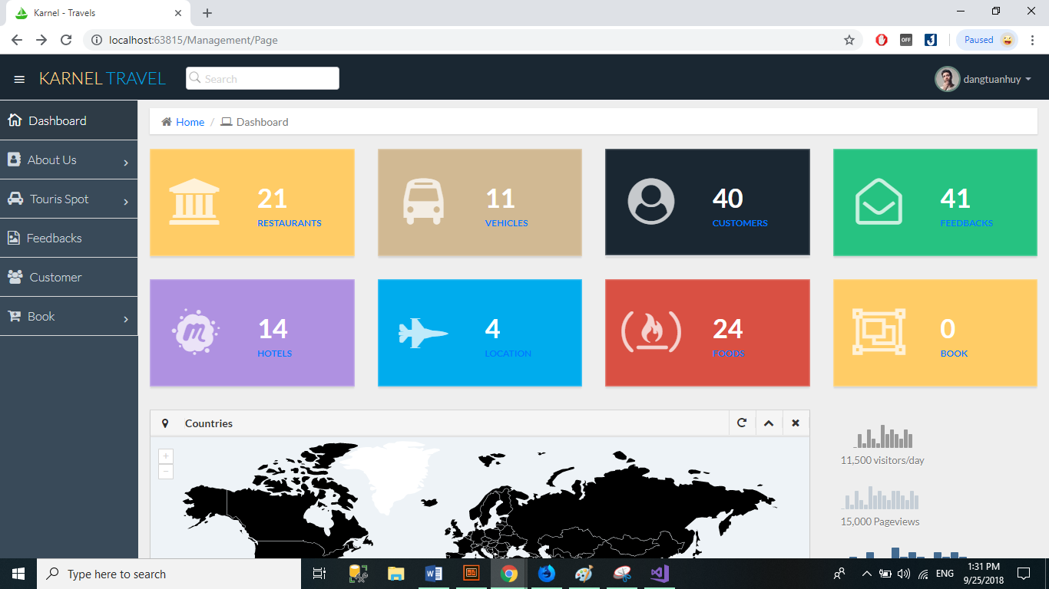Demo: List, Create, Edit, Delete, Upload Multiples File IMG (Hotel), upload Single file (Vehicle),
* 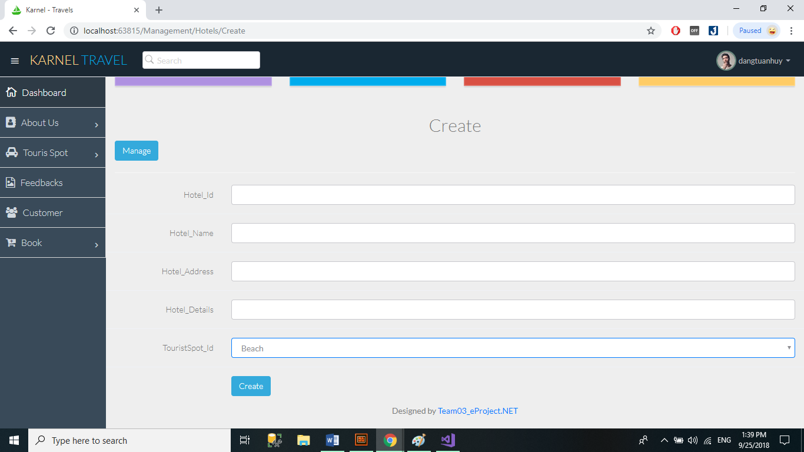Create Hotels
* 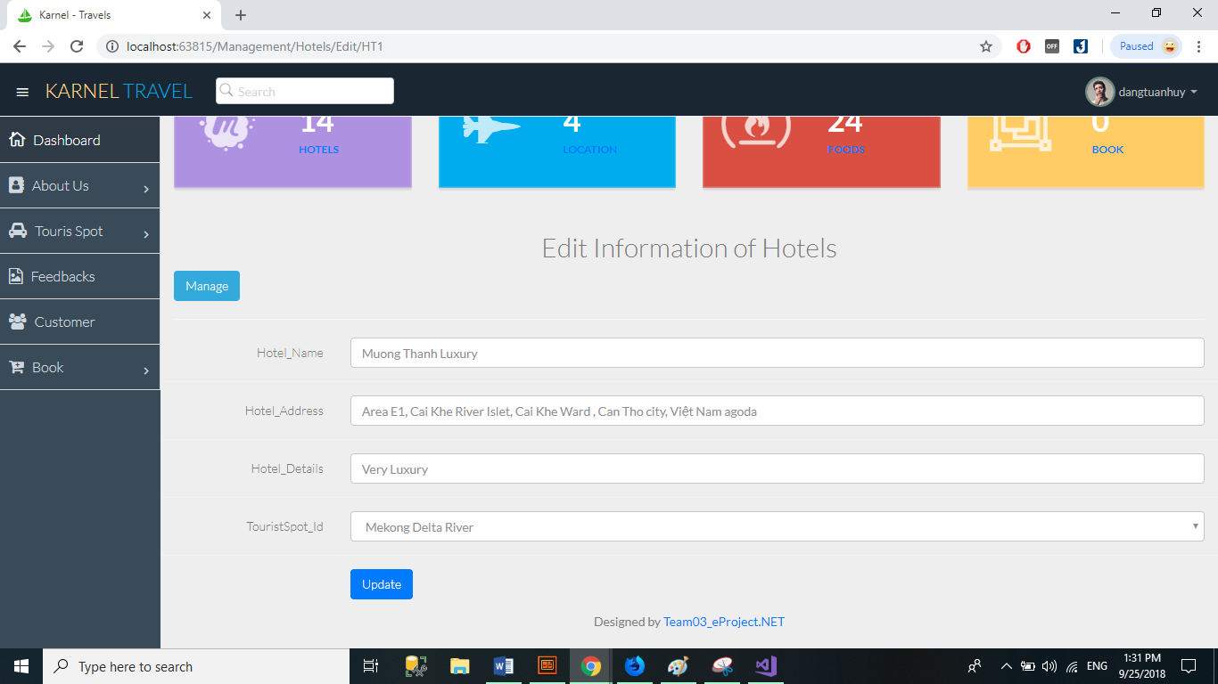Edit Hotels
* 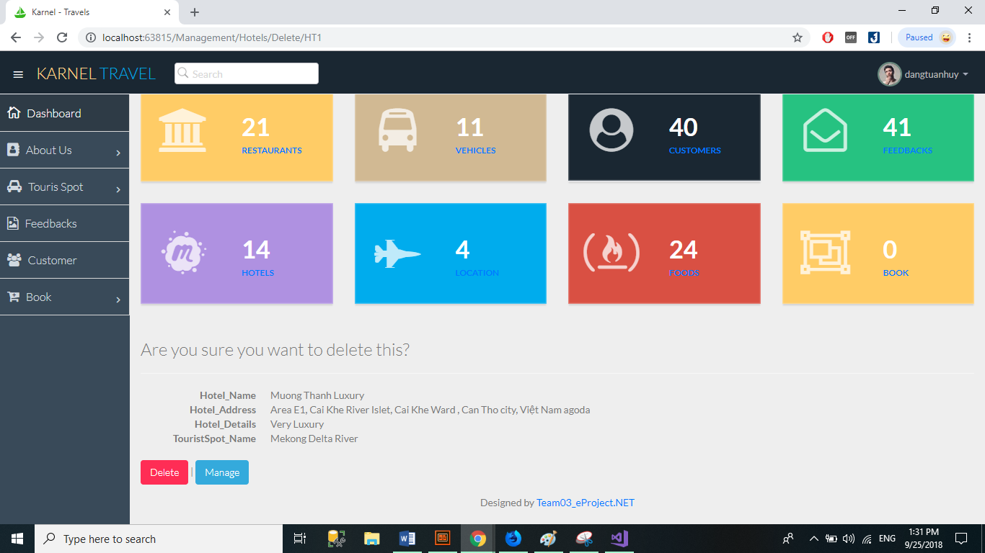Delete Hotels
* 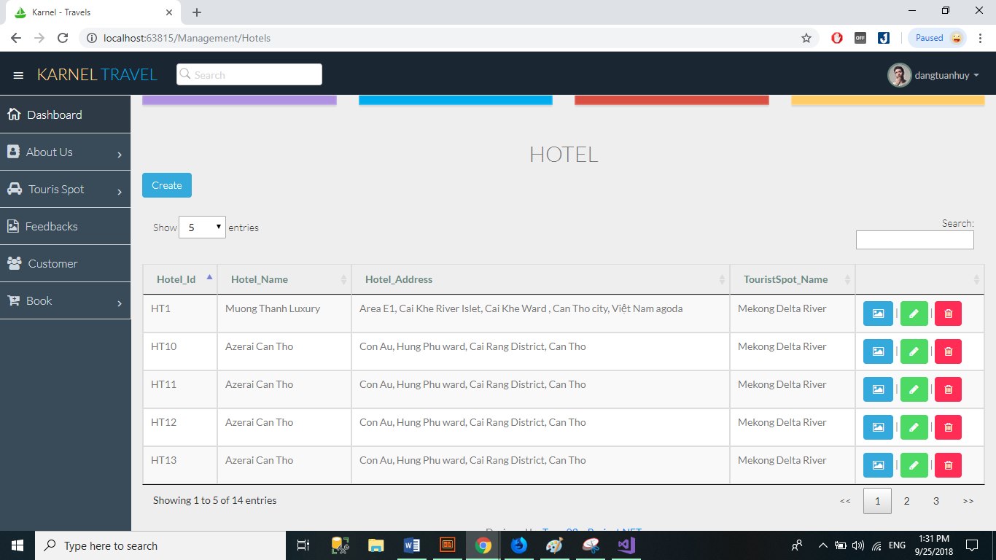List Hotels
* 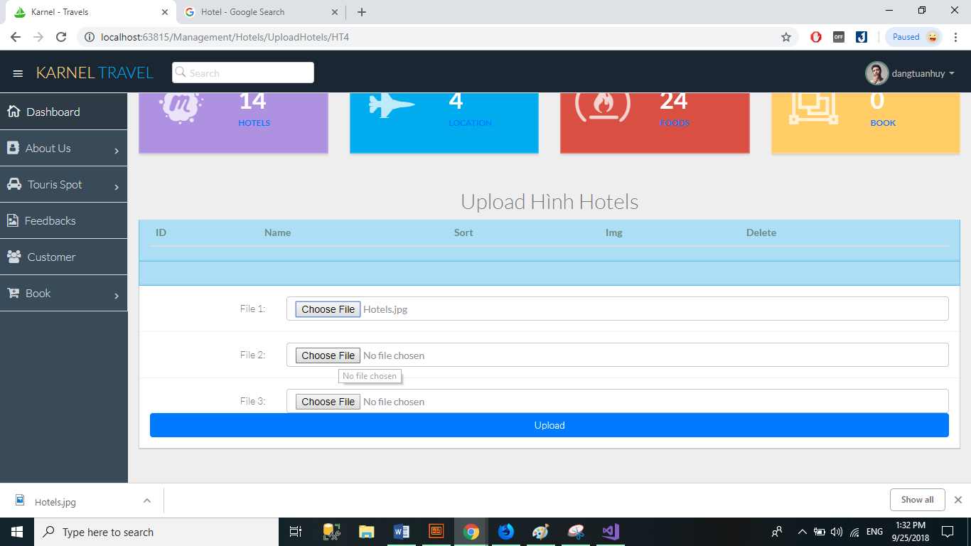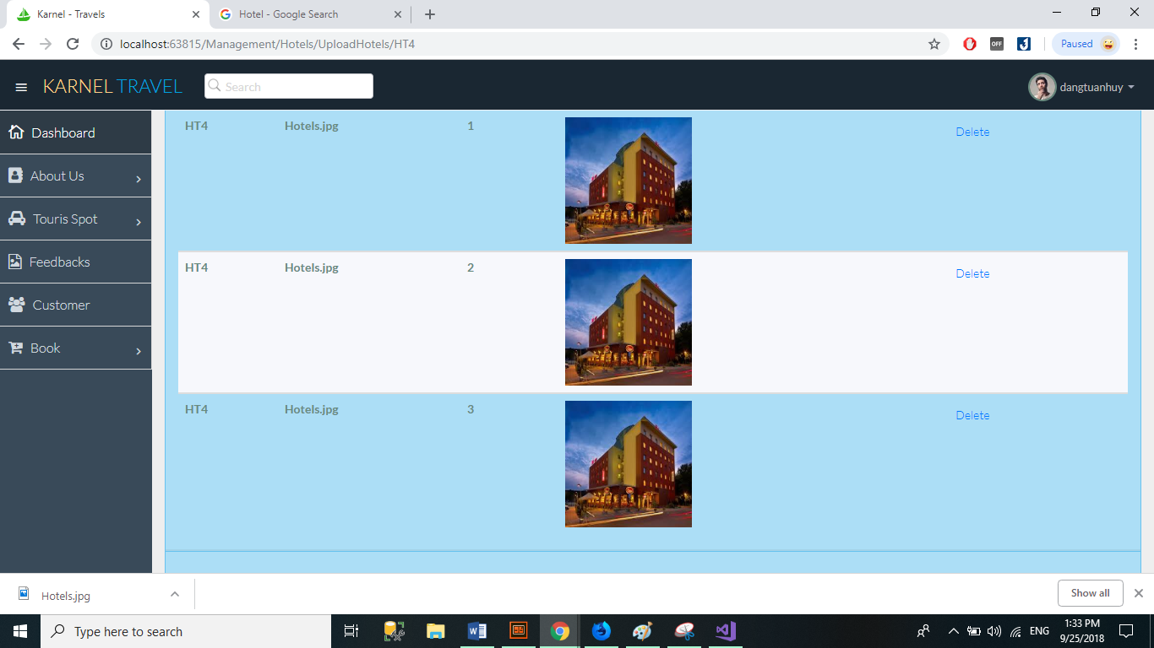Upload IMG Hotels
* 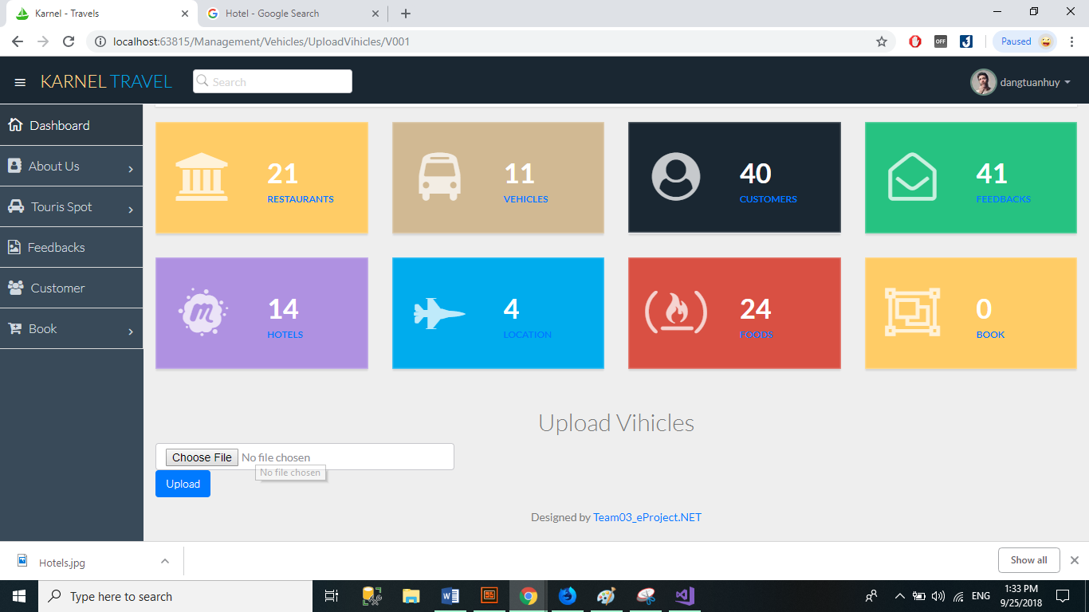Upload IMG Vehicles
* Statistics

13.3.3. User